**FR12**

Technical UAT observation on 29-May-22

## **Order By (descending) LIFO**

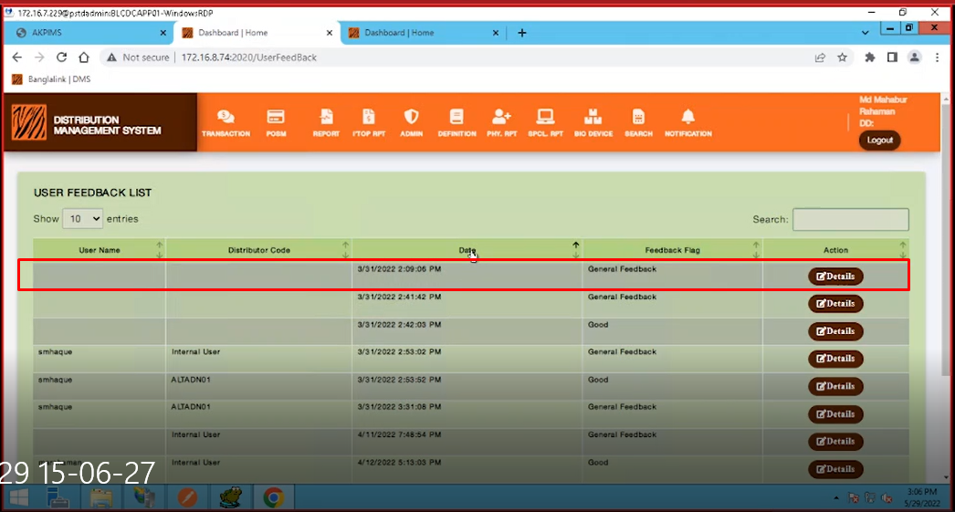

## **“Page Link” Font hight should be as like “Page URL”**

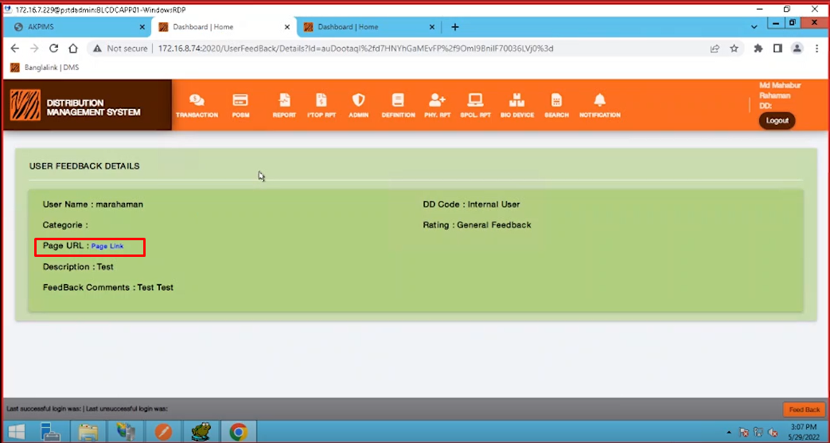

## **Category: Value (User friendly, Interactive etc.) Should be in same line with comma separated**

**FR13**

Not presented in the Technical UAT

**FR13**

Found OK

**FR-21**

1. Only Count should be shown against of user type.
2. Need 2/3-weeks data for testing purpose.

